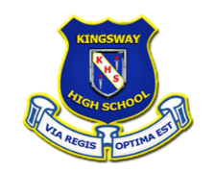
Kingsway High and Preparatory School

10-12 Osbourne Road, Kingston 10

Telephone: (876) 968-9179, (876) 926-2379 Fax: (876) 908-2050

Email: kingswayhighandprep@gmail.com

Request for Documentation/Records

Please allow five (5) working days for documents to be processed

Name while in attendance: Date of Birth:

Address (While attending):

Attendance Period - From: To: Current student:

Parent’s/Guardian’s Name(s):

Document(s) required (Please check the appropriate box)  Last/Current Report Card  Embassy Letter  Letter of Recommendation  Official Transcript of Grades __  Other________________________________ | Document(s) to be addressed to:
Document(s) to be: mailed ____ will be collected: _______  Name and number of available contact:  __________________________________________________  __________________________________________________ | Office Use Only:  Date of Request:_______________________  Date to be collected:____________________  Signature of Registrar: _________________

